Tutorial: http://blog.csdn.net/luyejie8888/article/details/38070579
Tutorial: http://beaglebone.cameon.net/home/autostarting-services
BBB tutorial
——Zhan Tu
- Drive need:(Onboard)
RNDIS(IP account)
CDCAMC(Windows unblock)
- Software:
Ubuntu: Code compiling and testing(same environment as BBB)
Putty: PC terminal
Geany:(ubuntu)C++ code programming and logic debugging
- Terminal (Linux level packaging and testing)
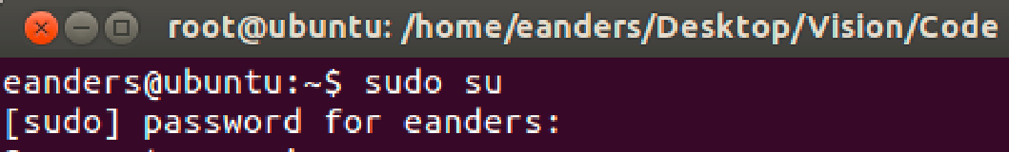g++ d
Password: （324那个+ tZ）
Packaging without OPENCV:
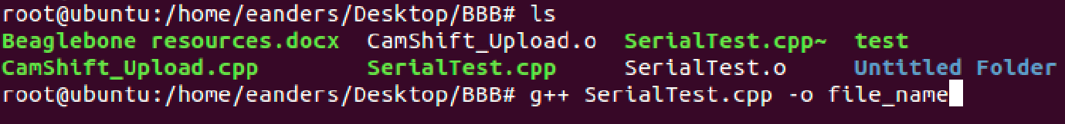
With OPENCV:
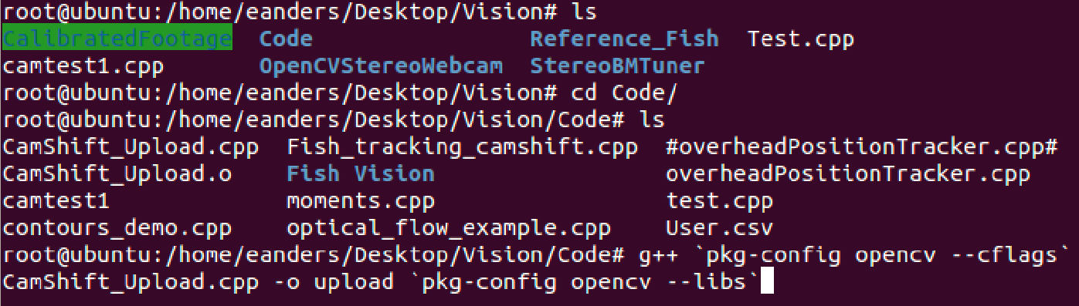
Command: g++ `pkg-config opencv --cflags` BBB_SerialZT.cpp -o BBB_ZT `pkg-config opencv --libs`. (其中的`是数字1左边的~和`键)
- Putty:
Host server, which could talk to BBB(operate and run)
IP address：192.168.7.2
Port: 22
Account：Root
Password: Return Key
If ubuntu could run pkg，we can directly pkg .o file based on putty in BBB.
Debug and temp run：./filename

- BBB-self?How to wire on monitor?
It’s broken. Need a USB-OSG wire. I’ll try VNC latter.
- How to put a pkg code in? (Putty+Usb)
- BBB level：
Upper level（bin;boot;dev;lib;home;mnt;run）
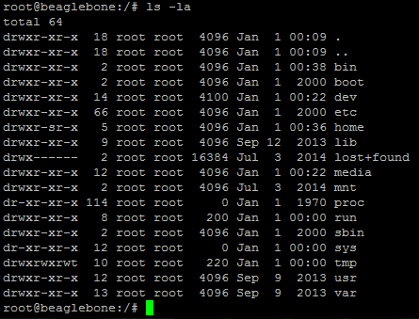
Normal files are in home folder（自建的usb文件mount在这一层）
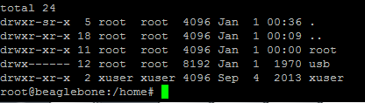
Desktop app is under ‘root’（各种.cpp和.o）
- File Copy
1.Check hardware drive first，the command is fdisk -l. Usually the name is sda* or sda1..etc
2.For example, sda1. Create a folder，and then mount flash drive file to this folder. (command ‘pwd’ could check current route, very important).
Create folder command is ‘mkdir /home/usb’（如已在home下，直接mkdir usb即可，命令行与路径间注意空格）。
- Mount hardware：mount /dev/sda1 /home/usb
(mount /usb-drive route /desired route)。
4.Go to ‘cd /home/usb’ and check whether this flash is the desired one
5.Command to copy a whole folder “cp –r folder/ destination/”`
Copy a single file: “cp file.txt destination/”
Copying from command line:http://www.thegeekstuff.com/2013/03/cp-command-examples/
6.Un-mount work: umount /dev/sda1

*fdisk -l or lsblk commands could help us check the hardware name, then start mount work
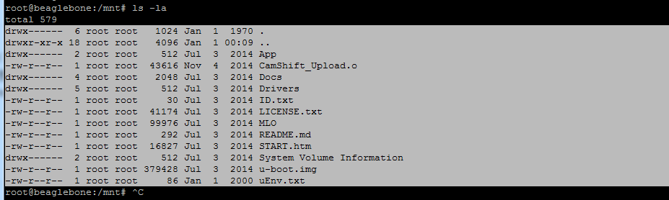

- How to set code auto-run in BBB?
- The file the makes it autorun is in folder: /lib/systemd/system
File name: MyService.se/rvice
To edit this file run command: nano MyService.service
Bingo：nano is a editing program command
- Ctrl+O to edit .service file name，press ’enter’ for sure （*commands：^X means ctrl+X）
- .service file Code：
[Unit]
Description=Fish Tracking
After=local-fs.target
[Service]
WorkingDirectory= /home/root/Desktop/BBB
ExecStart= /home/root/Desktop/BBB/FishZT
[Install]
WantedBy=multi-user.target
The only lines you should change are “WorkingDirectory” and “ExecStart”
Working directory is where any files the program references need to be. In this case, the reference image(s).
ExecStart is the file that runs on start .
Commands for the startup service file.
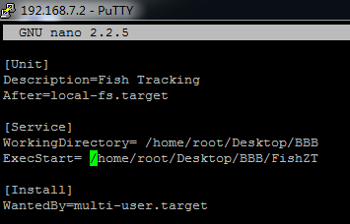
- Type: ctrl+x to exit service file programming. Then, enable and start this service file. Furthermore check the running status, commands as below:
systemctl enable MyService.service - this enables the service file. Run this if you change the file name or create a new service file.
systemctl start MyService.service - this starts the file auto run process without having to reboot the board.
systemctl status MyService.service - gives the status of the program that is running. Basically, shows the terminal output.
If it’s already running, use ’top’ (program processing edit) to see whether it real works or not.
- To kill the tracking program:
Use the command “top”. This shows all the top running programs, as seen below.
Command “k” and enter the PID number of the FishSerial command, then enter.
“q” to exit
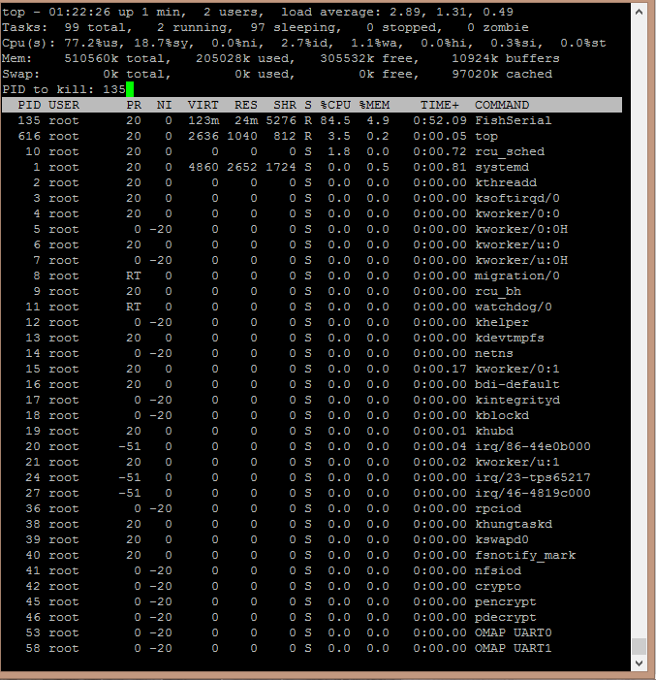
Useful websites:
http://beaglebone.cameon.net/home/autostarting-services
http://dcinglis.wordpress.com/2014/09/08/running-a-startup-script-on-a-beaglebone-black/

Beaglebone resources
How to enable ports: http://beaglebone.cameon.net/home/serial-ports-uart
This example is specifically for serial ports but with the correct "capemgr.enable_partno=" it works for any ports.
Serial Out Tutorial: http://www.webalice.it/fede.tft/serial_port/serial_port.html
Boost library: documentation: http://www.boost.org/doc/libs/1_57_0/doc/html/boost_asio/overview/serial_ports.html

Current Setup:
Serial port: P9-uart1
Pin 26=Uart1_RxD---------------------Mbed Pin13
Pin24=Uart1_TxD----------------------Mbed Pin14
Program: SerialZT.cpp, pkg file: FishZT.o
Path: /home/root/Desktop/BBB

Eric:
Current Setup:
Program SerialTest.cpp writes and reads over serial port UART1 with is pins 24 and 26. This shows up as ttyO1 in directory “/dev”.
Pin 26=Rx c
Pin24=Tx
You can change the pins by changing the enabled ports.
I updated CamShift_Upload.cpp so it works on beaglebone and tracks a tennis ball and outputs x and y coordinates to the terminal. Modify this with the SerialTest.cpp code to output the coordinates over serial.

